|  |  |  |  |  |
| --- | --- | --- | --- | --- |
|  |  |  |  | |
|  |  | |  |
|  |  |  | |  |
|  | BCTRA- SH 288 & FM 518 Intersection  Intersection Improvements  February 2014  Prepared by  HDR Engineering, Inc.  4635 Southwest Freeway  Suite 1000  Houston, Texas 77027 | | | |

Contents

1 Background Information 1

1.1 Project Need and Purpose 1

2 Phased Approach 2

2.1 Three Total Phases 2

2.2 Phase I: Bridge Construction 2

2.3 Phase II: Improvements to FM 518 Pavement 5

2.4 Phase III: Frontage Road Improvements 7

3 Summary 9

Figures

Figure 1‑1: Project Location Map 1

Figure 2‑1: Phase I 4

Figure 2‑2: Phase II 6

Figure 2‑3: Phase III 8

Exhibits

Exhibit 1 10

Exhibit 2 11

Exhibit 3 12

Exhibit 4 13

# Background Information

## Project Need and Purpose

Brazoria County has undergone significant population increases since the inception of SH 288 in 1985. Traffic demands are beyond current capacities leading to unacceptable levels of service. This report outlines the improvements to the intersection of SH 288 and FM 518. Improvement options became apparent during the ongoing BCTRA Toll lane project. BCTRA will construct a new bridge in between TxDOT’s North bound and south bound main lane bridges, thus “filling in the gap”. Building a new BCTRA bridge that matches current span configurations does NOT allow for future FM 518 expansion. BCTRA proposes to build their new bridge with longer spans to allow for future expansion of FM 518. The result is a new BCTRA bridge that allows for lane expansion. BUT the remaining TxDOT NB & SB bridges do not allow for lane expansion. All bridges must have matching span configurations before FM 518 lane improvements can be made. This requires reconstruction of TxDOT’s 2 bridges, NB & SB main lanes. This study identifies the work and costs to each owner entity that lead to the final intersection schematic as designed by TxDOT. After all improvements are made to the intersection and frontage roads, the LOS improves as per Exhibit 2. Figure 1-1 provides a map of the project location.

Figure ‑: Project Location Map



# Phased Approach

## Three Total Phases

This proposal presents 3 phases of work. All 3 phases, combined, lead to the final schematic plan as shown by TxDOT, see Exhibit 1. The 3 phases of intersection improvements are bridge construction, improvements to FM 518 pavement and frontage road improvements. It is the intent of this proposal to pursue Phased approach to achieving the ultimate intersection improvement.

## Phase I: Bridge Construction

Brazoria County Toll Road Authority (BCTRA) will build the middle toll bridge with a span configuration that allows for the expansion of FM 518. TxDOT will rebuild their NB and SB main lane bridges, with matching span configuration that allows for the expansion of FM 518. The existing islands require reconstruction. U-turns will require relocation and reconstruction. Soil nail walls are required to facilitate the new U-turn location. Below are costs broken out by owner entity.

|  |  |  |  |  |
| --- | --- | --- | --- | --- |
| **ITEM** | **QUANTITY** | **UNIT COST** |  | **COST** |
|  |  |  |  |  |
| **BCTRA ITEMS** |  |  |  |  |
| RAILING/BARRIER (LF) | 650.00 | $42.00 |  | $27,300.00 |
| SEALED EXP JTS. (LF) | 180.00 | $75.00 |  | $13,500.00 |
| DRILLED SHAFT 30" DIA (LF) | 1,620.00 | $115.00 |  | $186,300.00 |
| CL C CONC COL (CY) | 150.00 | $650.00 |  | $97,500.00 |
| DRILLED SHAFT 84" DIA (LF) | 540.00 | $650.00 |  | $351,000.00 |
| CL C CONC(ABUT) (CY) | 100.00 | $900.00 |  | $90,000.00 |
| CL C CONC CAP (INV T-CAP) (CY) | 235.00 | $800.00 |  | $188,000.00 |
| PRESTR CONC GIRDER Tx62 (LF) | 3,620.00 | $155.00 |  | $561,100.00 |
| CL S CONC (SLAB) (CY) | 750.00 | $500.00 |  | $375,000.00 |
|  |  |  | SUBTOTAL= | $1,889,700.00 |
|  |  |  | 33% CONTINGENCY= | $629,900.00 |
|  |  |  | BCTRA TOTAL= | $2,519,600.00 |
|  |  |  |  |  |
| **TXDOT ITEMS** |  |  |  |  |
| RAILING/BARRIER (LF) | 1,340.00 | $42.00 |  | $56,280.00 |
| DRILLED SHAFT 30" DIA (LF) | 2,160.00 | $100.00 |  | $216,000.00 |
| DRILLED SHAFT 84" DIA (LF) | 1,080.00 | $650.00 |  | $702,000.00 |
| SLAB (CY) | 1,150.00 | $525.00 |  | $603,750.00 |
| PRESTR CONC GIRDER Tx62 (LF) | 3,830.00 | $155.00 |  | $593,650.00 |
| CL C CONC ABUT (CY) | 165.00 | $900.00 |  | $148,500.00 |
| CL C CONC CAP (CY) | 325.00 | $800.00 |  | $260,000.00 |
| CL C CONC COL (CY) | 228.00 | $650.00 |  | $148,200.00 |
| SEALED EXP JTS. (LF) | 240.00 | $75.00 |  | $18,000.00 |
| REMOVE OLD STRUCTURE (LS) | 2.00 | $50,000.00 |  | $100,000.00 |
|  |  |  | SUBTOTAL= | $2,846,380.00 |
|  |  |  | 33% CONTINGENCY= | $948,793.33 |
|  |  |  | TXDOT TOTAL= | $3,795,173.33 |
|  |  |  |  |  |
| **ADDITIONAL SURFACE IMPROVEMENT COSTS** |  |  |  |  |
| SOIL NAIL WALLS (FACADE) ( SF) | 7500 | $55.00 |  | $412,500.00 |
| SOIL NAIL ANCHORS (LF) | 10000 | $20.00 |  | $200,000.00 |
| CRCP U-TURN QUANTY (SY) | 3000 | $60.00 |  | $180,000.00 |
| RIP RAP CONC ISLANDS (CY) | 400 | $400.00 |  | $160,000.00 |
| CURBS (LF) | 3000 | $3.00 |  | $9,000.00 |
|  |  |  | SUBTOTAL= | $961,500.00 |
|  |  |  | 33% CONTINGENCY= | $320,500.00 |
|  |  |  | SURFACE TOTAL= | $1,282,000.00 |
|  |  |  |  |  |
|  |  |  |  |  |
|  |  |  | PHASE I SUBTOTAL= | $7,596,773.33 |
|  |  |  | ADD 10% MOBILIZATION= | $759,677.33 |
|  |  |  | PHASE I TOTAL= | $8,356,450.67 |

Figure ‑: Phase I

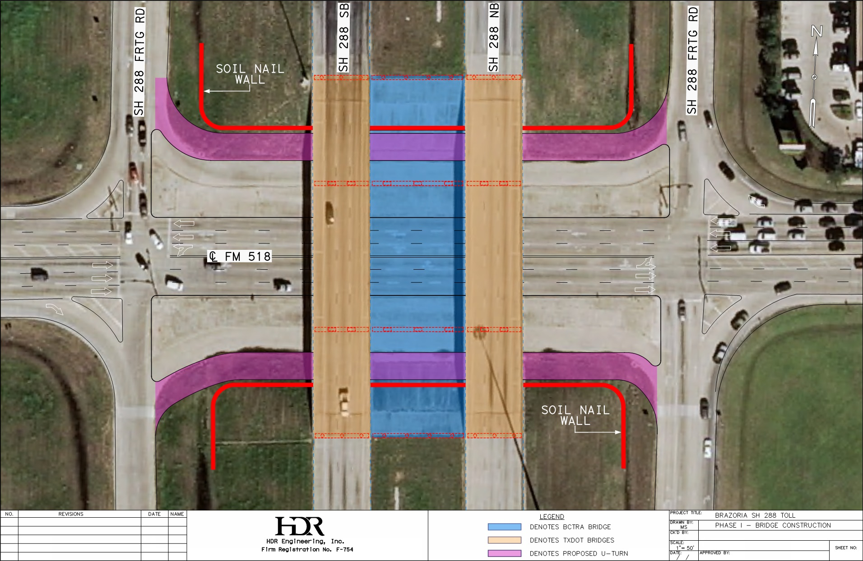

## Phase II: Improvements to FM 518 Pavement

Build 10 lanes of FM 518 (5 lanes ea. direction), beneath new bridges, for a distance of 850 feet, measured along CL of FM 518.

|  |  |  |  |  |
| --- | --- | --- | --- | --- |
| **ITEM** | **QUANTITY** | **UNIT COST** |  | **COST** |
|  |  |  |  |  |
| **PHASE II ITEMS** |  |  |  |  |
| CRCP RECONSTRUCTION (SY) | 13000 | $60.00 |  | $780,000.00 |
| RIP RAP CONC ISLANDS (CY) | 300 | $400.00 |  | $120,000.00 |
| CURBS (LF) | 3000 | $3.00 |  | $9,000.00 |
| ADD SIGNALIZATION (LS) | 1 | $300,000.00 |  | $300,000.00 |
|  |  |  | SUBTOTAL= | $1,209,000.00 |
|  |  |  | 33% CONTINGENCY= | $403,000.00 |
|  |  |  |  |  |
|  |  |  |  |  |
|  |  |  | PHASE II SUBTOTAL= | $1,612,000.00 |
|  |  |  | ADD 10% MOBILIZATION= | $161,200.00 |
|  |  |  | PHASE II TOTAL= | $1,773,200.00 |

Figure ‑: Phase II

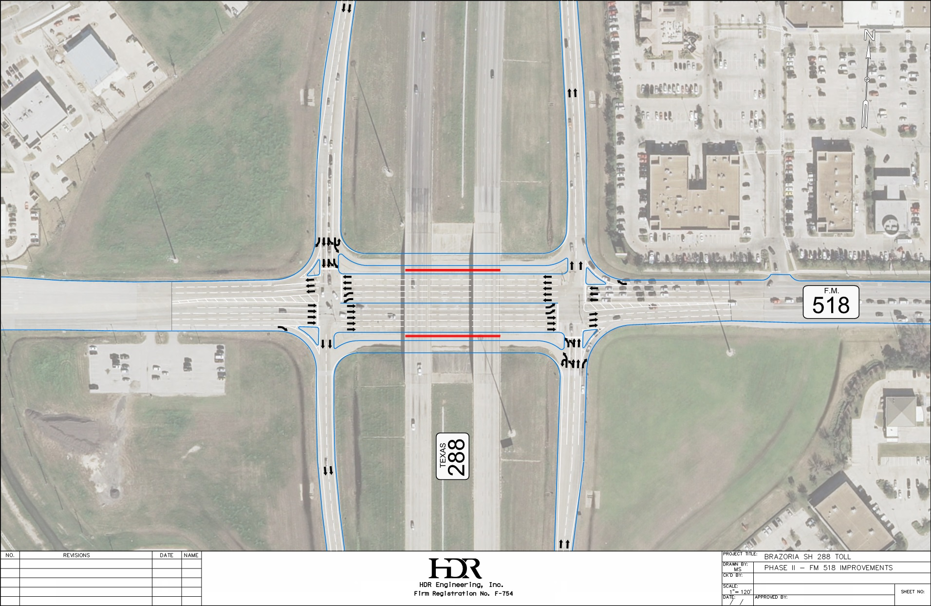

## Phase III: Frontage Road Improvements

This is the final piece of work to provide lane balance to Phase I & II work. These improvements are based on the preliminary schematic acquired from TxDOT.

|  |  |  |  |  |
| --- | --- | --- | --- | --- |
| **ITEM** | **QUANTITY** | **UNIT COST** |  | **COST** |
|  |  |  |  |  |
| **PHASE III ITEMS** |  |  |  |  |
| CRCP RECONSTRUCTION (SY) | 10000 | $60.00 |  | $600,000.00 |
| RIP RAP CONC ISLANDS (CY) | 75 | $400.00 |  | $30,000.00 |
| CURBS (LF) | 1000 | $3.00 |  | $3,000.00 |
| SOIL NAIL WALLS (FACADE) (SF) | 65000 | $55.00 |  | $3,575,000.00 |
| SOIL NAIL ANCHORS (LF) | 58000 | $20.00 |  | $1,160,000.00 |
| ADD SIGNALIZATION (LS) | 1 | $300,000.00 |  | $300,000.00 |
| ADD 4 HI MAST LIGHTS (LS) | 1 | $340,000.00 |  | $340,000.00 |
|  |  |  | SUBTOTAL= | $6,008,000.00 |
|  |  |  | 33% CONTINGENCY= | $2,002,666.67 |
|  |  |  |  |  |
|  |  |  |  |  |
|  |  |  | PHASE III SUBTOTAL= | $8,010,666.67 |
|  |  |  | ADD 10% MOBILIZATION= | $801,066.67 |
|  |  |  | PHASE III TOTAL= | $8,811,733.33 |

Figure ‑: Phase III

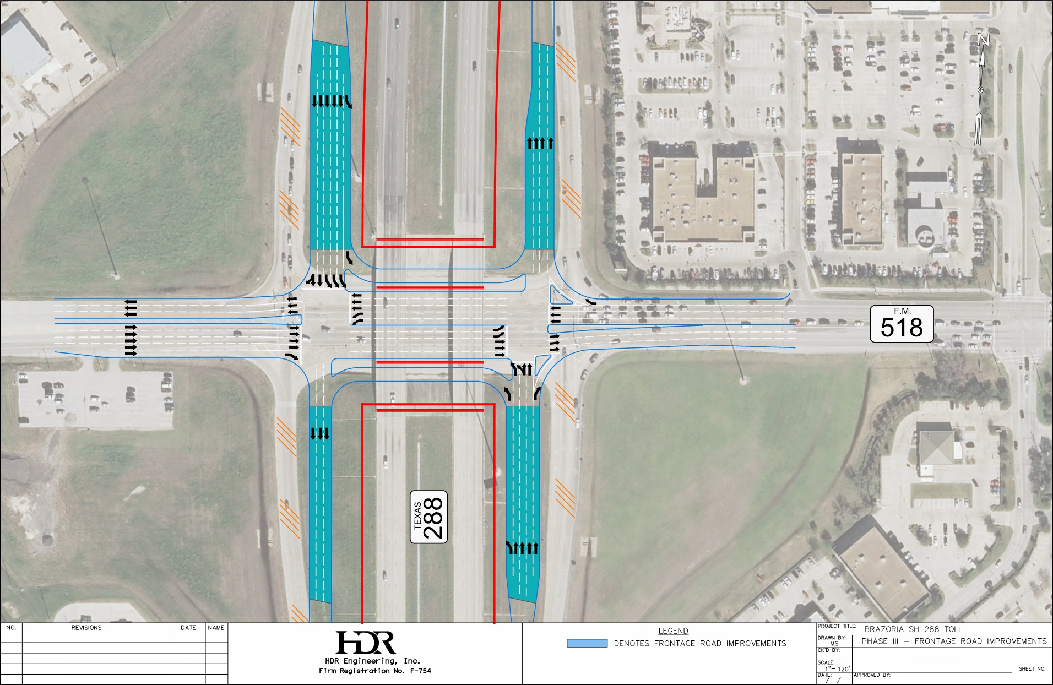

# Summary

The owner entities (BCTRA, TxDOT, and The City of Pearland) have met with the HGAC to determine the best approach to achieve the desired ultimate intersection improvements. To take advantage of the pending BCTRA Toll road construction it was determined that the best approach was to implement the ultimate intersection plan in phases. This report outlines the work and costs associated with each phase of the work.

Exhibit

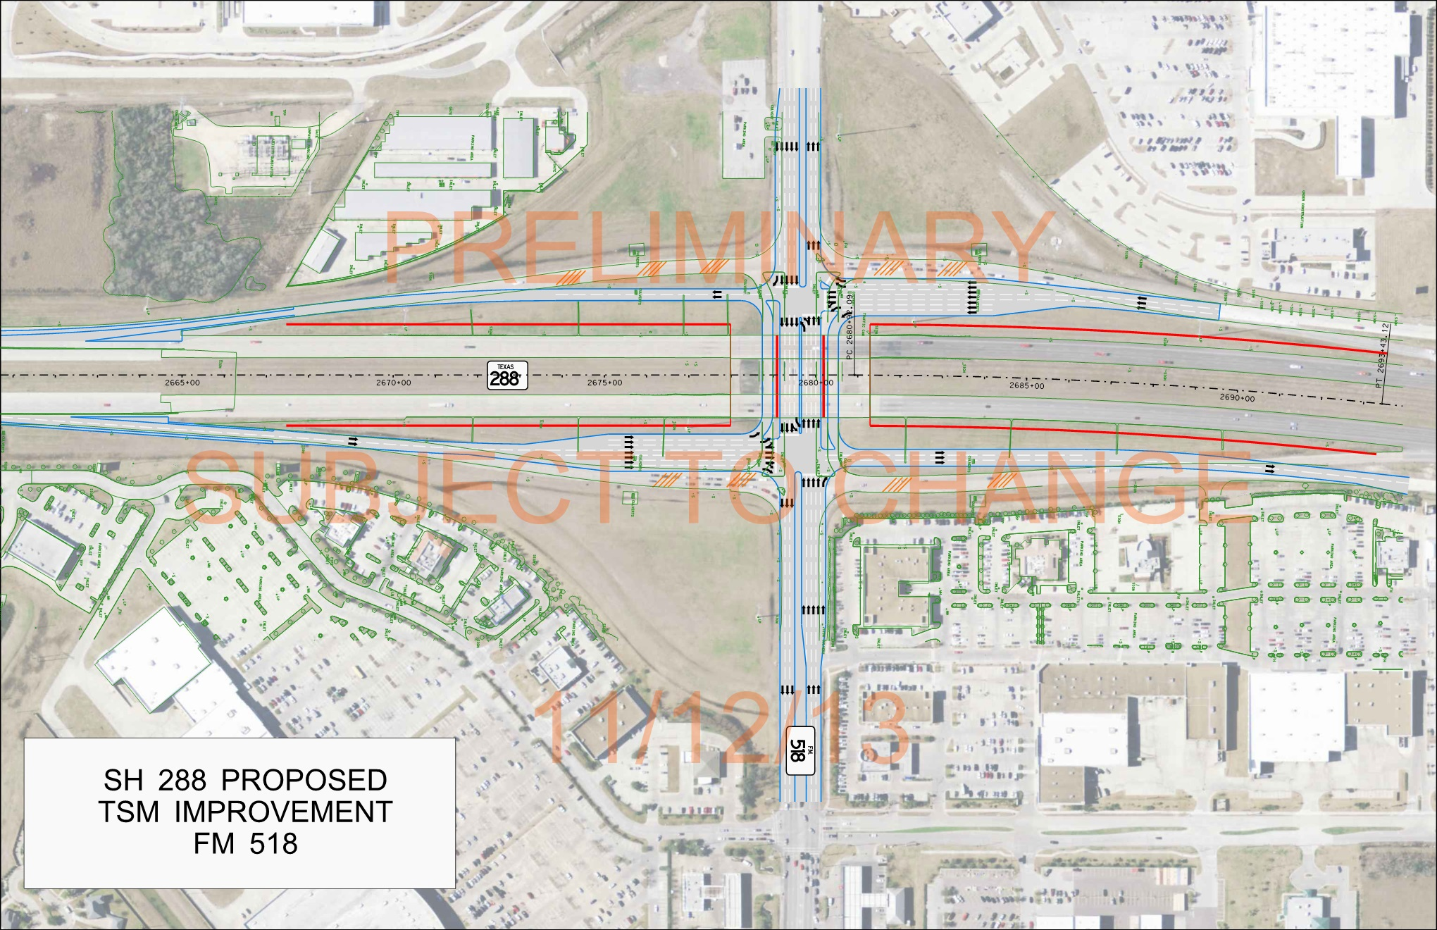

Exhibit



Exhibit



Exhibit

