May 2026 Social Media Captions –
Facebook
May 5  May-FB-Image-1 | Ready to part with that old bookcase or sofa? 🛋️ Large furniture items often require a "Bulky Waste" pickup or a trip to a neighborhood depository. Never leave them on the curb without checking your local schedule first! 📍 Note: Check with your municipality or waste hauler to find out what's accepted in your community. #FurnitureDisposal #RecycleRight #GulfCoastRecycles
May 12  May-FB-Image-2 | If it’s time to upgrade your TV, what will you do with the old one? Used electronics contain materials that shouldn't end up in a landfill. Many electronics can be refurbished or stripped for precious metals at specialized drop-off locations!  📍 Note: Check with your municipality or waste hauler to find out what's accepted in your community, check community calendars for special waste drop off opportunities, or visit Earth911 to search for programs that accept specific technology items, like televisions and computers. #LivingRoomCleanout #HGACRecycles #TechTidying
May 19  May-FB-Image-3 | 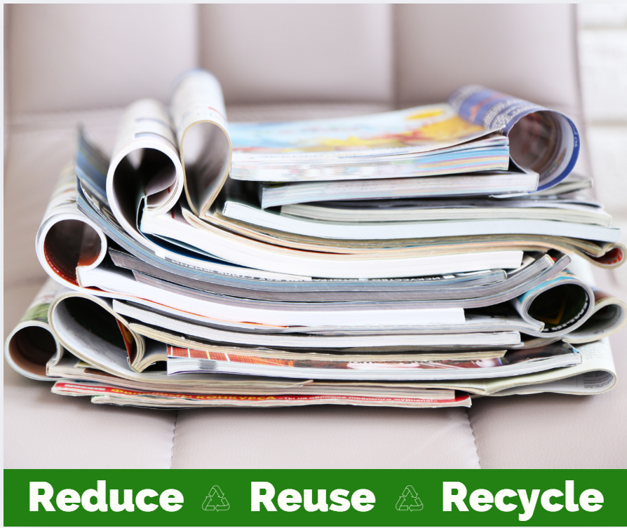Are those old magazines and catalogs weighing you down? 📖 Good news: shiny or glossy paper is fine for your curbside recycling bin! Just make sure to remove any plastic wrap or product samples stuck inside before tossing them in. 📍 Note: Check with your municipality or waste hauler to find out what's accepted in your community. #RecycleRight #LivingRoomRefresh #PaperRecycling #GulfCoastRecycles  https://earth911.com/recycling-guide/how-to-recycle-books-magazines/
May 26  May- -FBImage-4 | 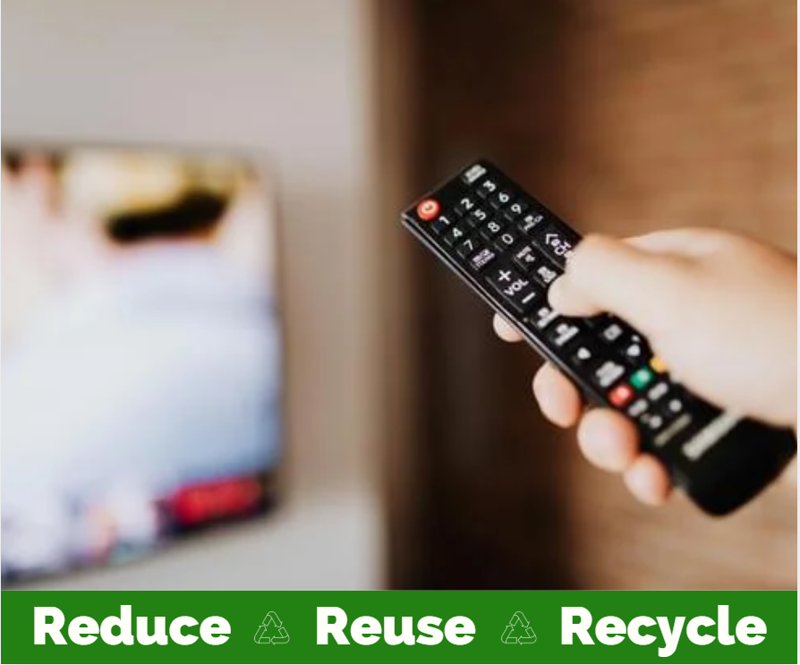  We all know remote control batteries don’t last forever, but what do we do with them? 🔋 Household batteries (especially lithium-ion) can be a fire hazard if put in your curbside bin. Keep a small box in your living room to collect spent batteries, then take them to a local retail drop-off or hazardous waste event! 📍 Note: Check with your municipality or waste hauler to find out what's accepted in your community or take a look at these resources from earth911.com. #BatterySafety #HGAC #SafeDisposal #HomeMaintenance

Instagram
May- IGImage-1 | Recycling around the House -Living Room Edition! 🛋️ Our "Room-by-Room" series continues. Do you know what you find in your living room that can and can’t go in your recycle bin?  Magazines & Catalogs: Curbside 🆗! (Just lose the plastic mailer).  Remote Batteries: Curbside 🚫! Take these to a local battery drop-off.  Used Electronics (TVs/Game Systems): Curbside 🚫! These need a special recycling center visit.  📍 Note: Check with your municipality or waste hauler to find out what's accepted in your community.
May- IGImage-2- | Ready to part with that old bookcase or sofa? 🛋️ Large furniture items often require a "Bulky Waste" pickup or a trip to a neighborhood depository. Never leave them on the curb without checking with your municipality or waste hauler to find out what's accepted in your community.

X, formerly known as Twitter ((MAX 280 characters including spaces!)
May- -XImage-1- | 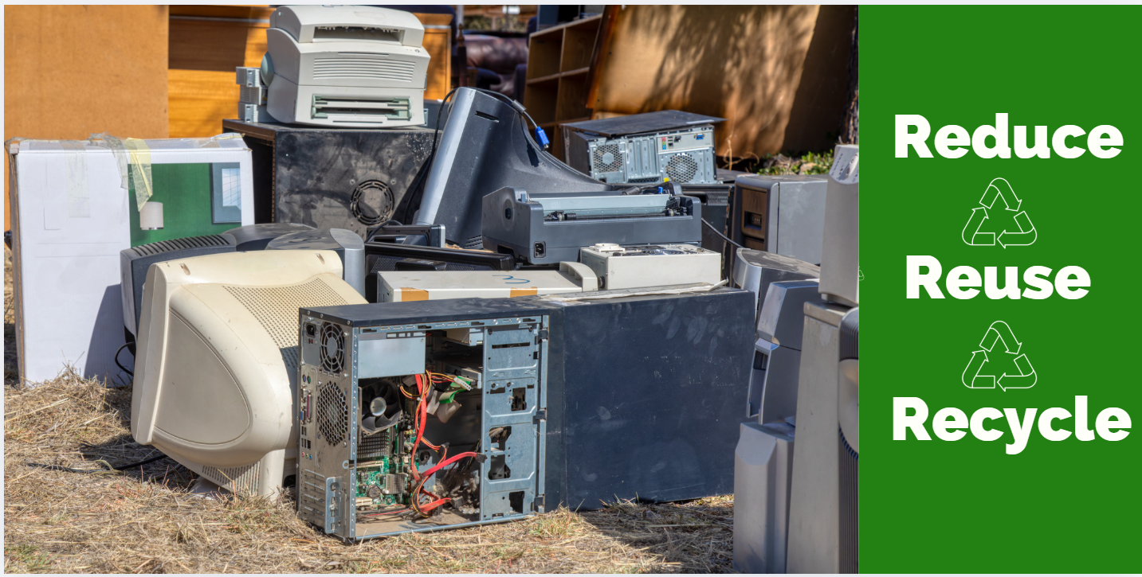Don't let old tech gather dust in the living room! 📺🎮 Used electronics require special handling. Find a local drop-off center instead of using your curbside bin. 📍 Note: Check with your municipality/hauler for local rules.
May- -XImage-2- | 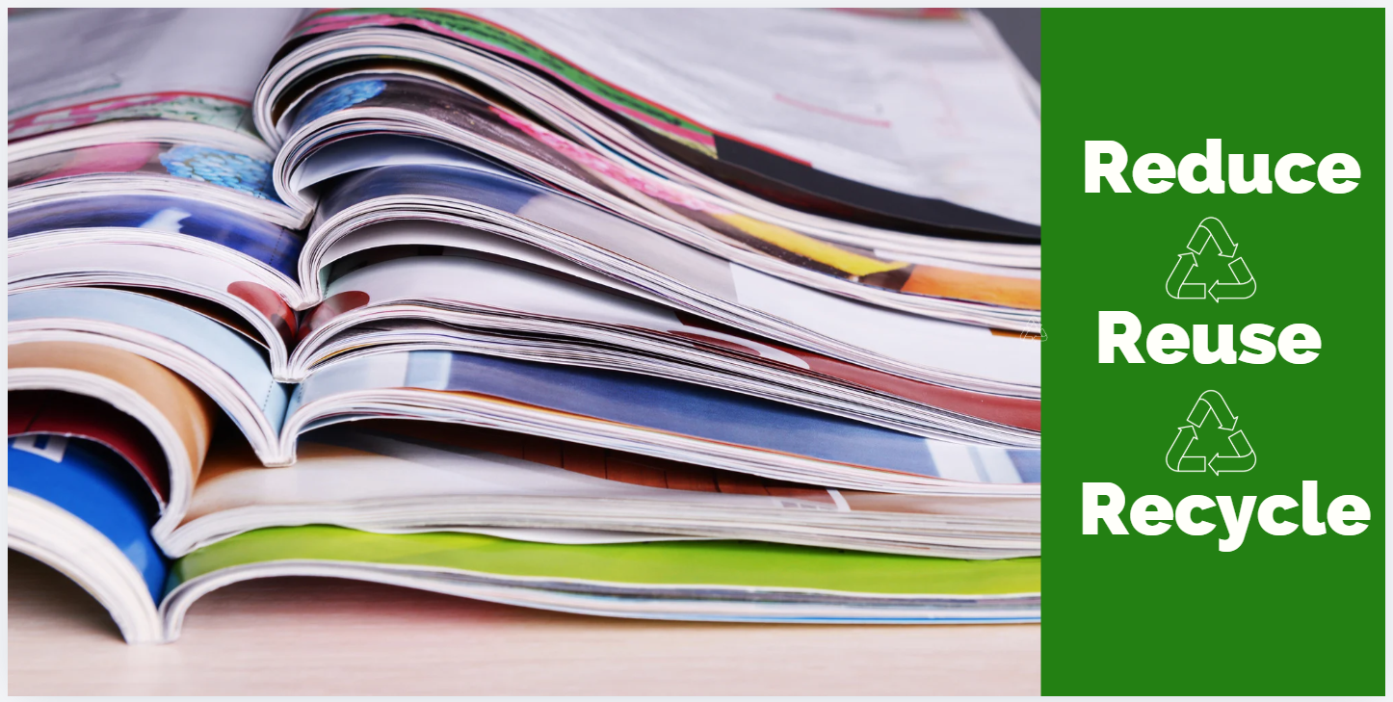☕ Magazines and catalogs are curbside-friendly! Just remember to remove any plastic film or "sticky" samples first. 📍 Note: Check with your municipality/hauler for local details.

