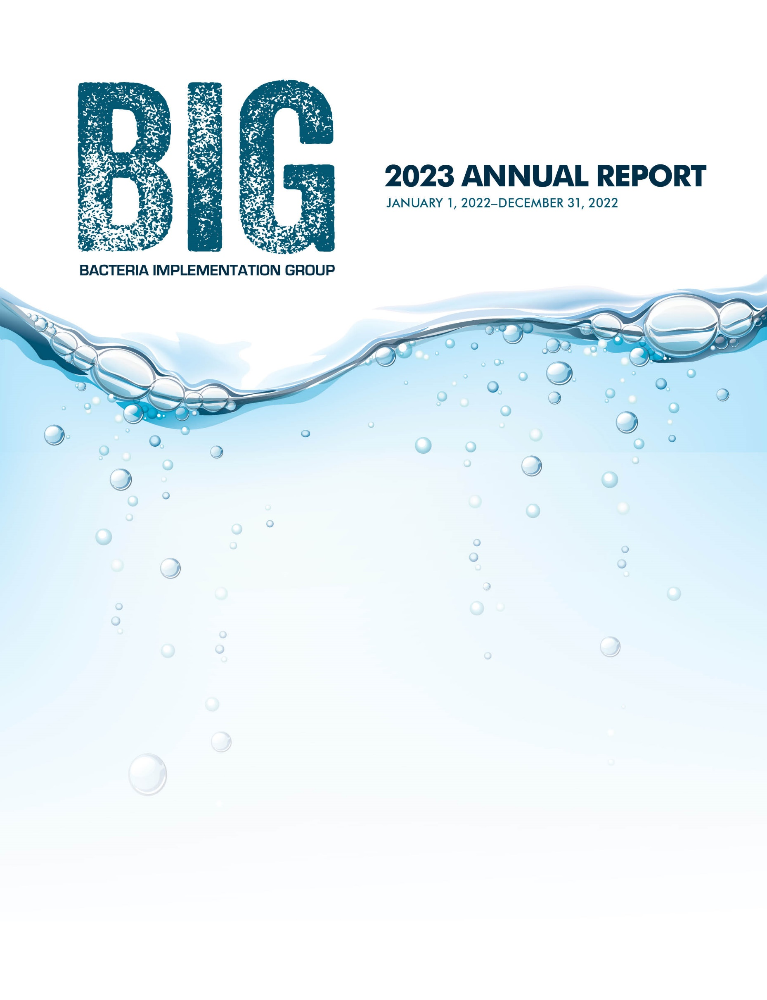

Implementing
the BIG I-Plan
The 33-member Bacteria Implementation Group (BIG) consists of government, business, and community leaders working with other stakeholders to implement the BIG Implementation Plan (I-Plan), a plan to help reduce bacteria in area waterways.

BIG Members*
Chris Baecke, Harris County (Urban County)
Lauren Boggs, Harris County (Urban County)
Ralph Calvino, Terracon (Business/Industry)
Jesuina Chipindula, City of Houston (Large City)
Tom Douglas, Houston Sierra Club (Conservation)
Colleen Gilbert, Greens Bayou Coalition (Conservation)
Teague Harris, IDS Engineering Group (Utility District)
Sam Hill, Texas A&M Forest Service (Agriculture)
Andrew Isbell, Walker County (Rural County)
Carol LaBreche, City of Houston (Large City)
Michael Lee, US Geological Survey (Resource Agency/Academia)
Paul Nelson, Bayou Preservation Association (Conservation)
Scott Nichols, Montgomery County (Rural County)
Becky Olive, AECOM (Business/Industry)
Mitchell Page, Schwartz, Page & Harding, LLP (Utility District)
Linda Pechacek, LDP Consultants, Inc. (Public)
Sonia Phillips, City of League City (Small City)
Jim Robertson, Cypress Creek Flood Control Coalition (Conservation)
Christine Santiny, City of Conroe (Small City)
Jamie Shakar, City of Houston (Large City)
Linda Shead, Texas Coastal Partners (Conservation)
Brian Shmaefsky, Lone Star College, Kingwood (Resource Agency/Academia)
Shane Simpson, San Jacinto River Authority (Business/Industry)
Robert Snoza, Harris County Flood Control District (Urban County)
Liz Stone, Quiddity Engineering (Business/Industry)
Michael Thornhill, SI Environmental (Utility District)
Scott Tuma, (Business/Industry)
Joanna Wilson, Gulf Coast Authority (Business/Industry)
Natasha Zarnstorff, Galveston Bay Foundation (Conservation)
Vacant, (Agriculture)
Vacant, (Conservation)
Vacant, (Rural Small City)
Vacant, (Agriculture - County)
* Member list effective as of June 11, 2024.
Parenthetical indicates type of organization represented

BIG Alternates*
Shaun Austin, Gulf Coast Authority
Paola Belloni, Terracon
Camila Biaggi, Quiddity Engineering
Matt Carpenter, SI Environmental (Utility District)
Nuguent Cotton, Harris County
Libby Decker, Terracon
Tom Douglas, Public
Robert Fiederlein, Greens Bayou Coalition
Brittani Flowers, Bayou Preservation Association
Frank Green, Montgomery County
Greg Hall, City of Conroe
Jody Hooks, City of League City
Steve Hupp, Cypress Creek Flood Control Coalition
Karen Kottke, AECOM
Haile Leija, Galveston Bay Foundation
Jeff Lu, Harris County
Zulimar Lucena, US Geological Survey
Reuben Martinez, Montgomery County
Carl Masterson, Texas Coastal Partners
Jonathan D. Mills, US Geological Survey
Lisa Montemayor, City of Houston
Scott Saenger, Quiddity Engineering
Aaron Schindewolf, San Jacinto River Authority
Julia Schmidt, Texas A&M Forest Service
Lisa Scobel, Galveston Bay Foundation
Rose Sobel, Bayou Preservation Association
Desta Takie, City of Houston
Lam Tran, City of Houston
Roberto Vega, Harris County Flood Control District
Jim Williams, Sierra Club
*Alternate list effective as of June 11, 2024.
Many stakeholders participated in actions in support of the I-Plan, many of which are documented in this Annual Report

Be Part of the Solution
The BIG project is and will continue to be successful in no small part to the individual actions of each stakeholder. We are eager to build on each success and seek the continued commitment of our partners and renewed interest and participation of our stakeholders.
Most of the implementation activities in the I-Plan are voluntary. Municipal Separate Storm Sewer Systems (MS4) Phase I and Phase II operators, local governments, farmers and ranchers, septic system owners, pet owners, and residents can help reduce the number of bacteria entering waterways by selecting one or more of these activities to implement.
Learn more by visiting
www.h-gac.com/BIG.

The Houston-Galveston Area Council (H-GAC) facilitates the BIG and supports and supplements implementation of the I-Plan through a grant from the Texas Commission on Environmental Quality (TCEQ).

EXECUTIVE SUMMARY
Nearly half of the Houston-Galveston region’s stream and shoreline miles continue to have bacteria levels higher than state standards for contact recreation. High bacterial concentrations may cause gastrointestinal illnesses or skin infections in swimmers or others who come into direct contact with the water (Figure 1). Fecal wastes come from a variety of sources, including humans, pets, domesticated animals, wildlife, and invasive species, such as feral hogs.
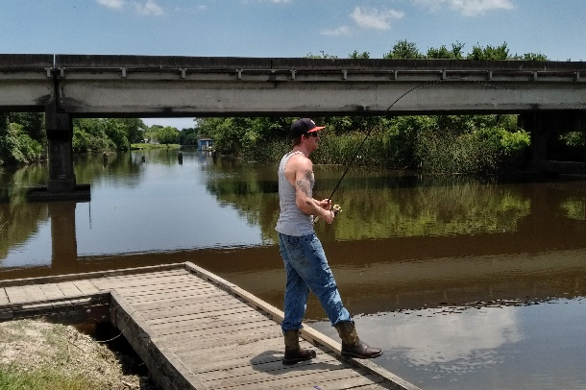
Figure 1. Water is always a big draw for recreation.
Since 2008, a group of government, business, and community leaders have joined together as members of the Bacteria Implementation Group (BIG) to develop and implement a plan, the BIG Implementation Plan (I-Plan), to reduce bacteria and improve water quality. The Texas Commission on Environmental Quality (TCEQ) approved the I-Plan (formally known as the Implementation Plan for Seventy-Two Total Maximum Daily Loads (TMDL) for Bacteria in the Houston-Galveston Region) on January 31, 2013.
The 2023 Annual Report is designed to track progress made in the BIG Project Area (Figure 2) from January 1, 2022, to December 31, 2022.

Making Progress
The good news is we are making a difference. Overall, bacteria levels for waterways in the BIG project area have decreased or remained stable since the BIG began working to address the problem in 2008. Even during a period of continued population growth and area-wide development pressure.
Bacteria levels in waterways have decreased from above six times the state’s contact recreation standard to four times the standard (Figure 3). Between 2015 and 2022, bacteria conditions have improved in 11 assessment units (AU), remained stable in 119, while deteriorating in 14 of the 144 AUs reviewed within the BIG Project area. In fact, two AUs, 1004_01 and 1004D_01 on the West Fork of the San Jacinto River and Crystal Creek, respectively, now meet the contact recreation standard and were delisted for the TCEQ’s 2016 Texas Integrated Report.

BIG Project Area
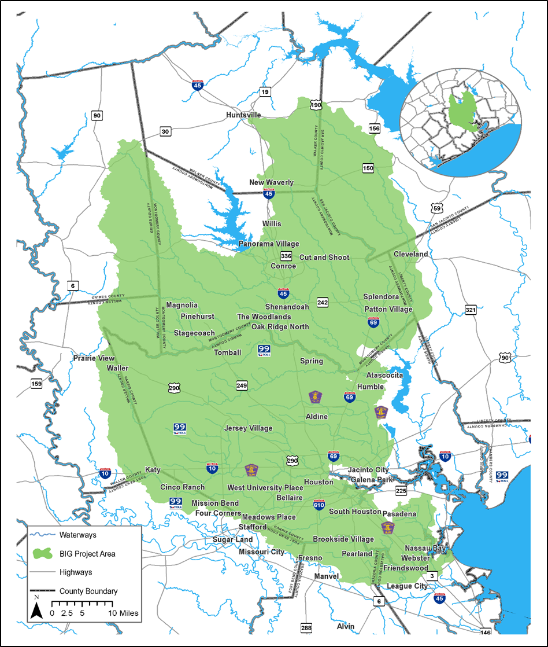
Figure 2. The BIG project area is approximately 3,260 square miles and has a population of nearly five million people. The area encompasses part of 10 counties, much of the City of Houston, and all or part of another 63 cities.
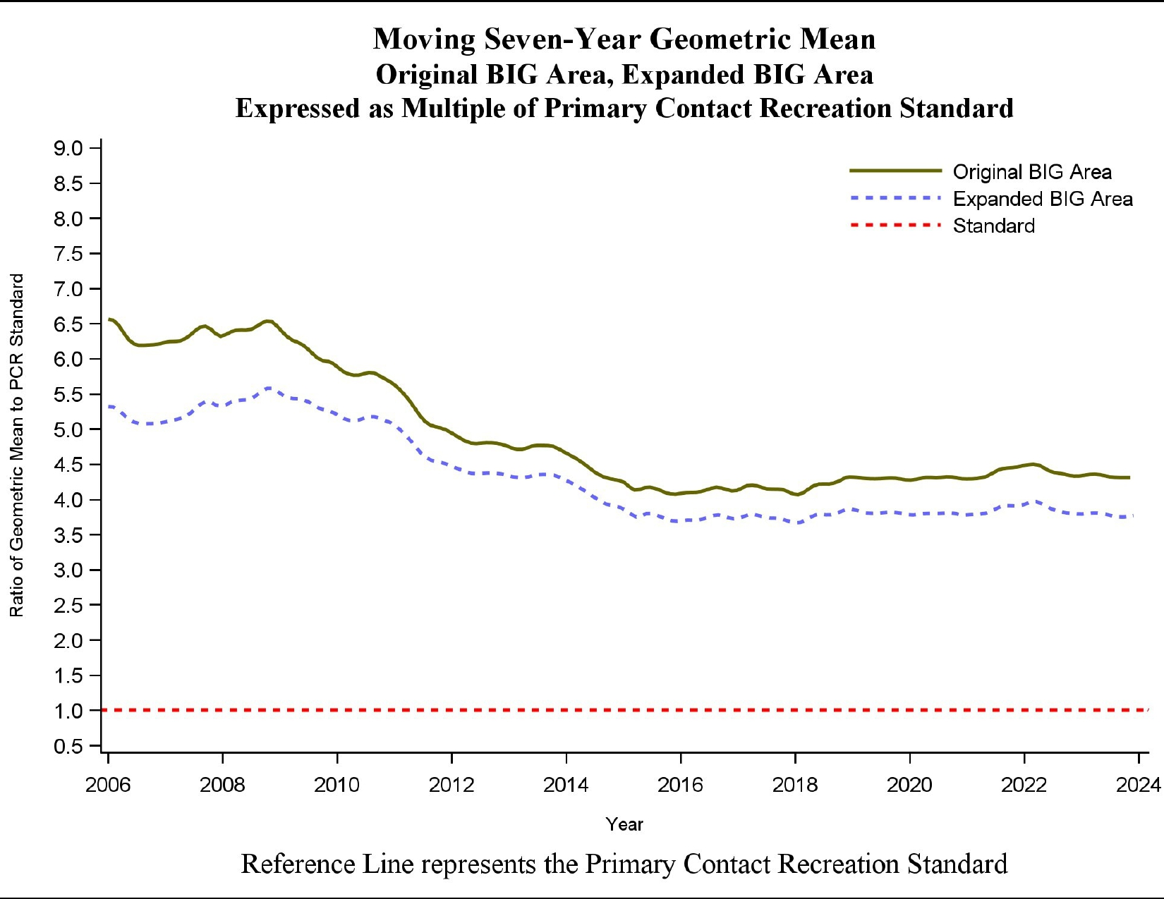
Figure 3. Bacteria trend lines for the BIG, Original Project Area and Expanded Project Area 2006-2023.

As a region, we have seen progress, however as Figure 3 shows, the bacteria trend has leveled out with a perceptible increase in recent years. There is more work to do for the BIG and the region if goals of the I-Plan – to reduce bacteria concentrations in the region’s waters and eventually fully support contact recreation, are to be accomplished.
Many stakeholders are actively implementing and tracking progress. Partners within the BIG are examining the effectiveness of implementation activities in reducing bacteria, including installing and monitoring structural best management practices; addressing bacteria impairments as part of their municipal separate storm sewer system (MS4) program; committing resources to address aging and failing infrastructure (Figure 4); educating and training local wastewater treatment operators, developers, and water quality service providers; and conducting public education and involvement campaigns.
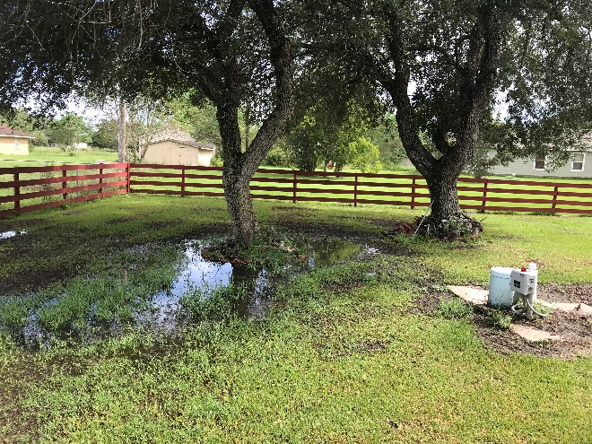
Figure 4. Failing onsite sewage facility
By working together, the BIG and its partner organizations can continue to identify what is working and what remains to be implemented.
Since the first annual report was published in 2013, the BIG project area (Figure 2) has expanded. The first expansion included the Armand Bayou TMDL project area in 2015. The second expansion in 2016 included the East and West Fork of the San Jacinto TMDL project Area. The last expansion incorporated the Jarbo Bayou watershed in 2018. The original project area was 2,202.7 square miles. The expanded area is now 3,259.89 square miles, roughly the size of Delaware and Rhode Island, combined. The I-Plan was initially written for 72 TMDLs. With additional TMDLs completed within the BIG project area and with the expanded area, the I-Plan now covers 126 TMDLs.

Watershed Protection Plans
H-GAC is working with the Texas Commission on Environmental Quality to expand watershed protection plans (WPP) within the BIG Project Area. WPPs are similar in process to the I-Plan established for the BIG. WPPs that are created will focus on smaller watersheds within the BIG project area. The goal of each watershed protection plan will be to encourage local watershed stakeholders to participate in plan development, to address water quality concerns, and for eventual plan execution.
The result of the watershed protection plan enactment within the BIG project area is expected to be more granular. Implementation of WPPs is anticipated to happen alongside implementation of the BIG I-Plan.
By the end of 2022, H-GAC had established stakeholder groups within five watersheds. The plans have been completed in two, having been approved by the U.S. EPA. Two are in review by the U.S. EPA. The remaining one is currently being developed. The five watershed WPPs are:
- West Fork of the San Jacinto River WPP
- Spring Creek WPP (in review)
- Cypress Creek WPP
- Clear Creek WPP (in review)
- East Fork of the San Jacinto River WPP (in development)

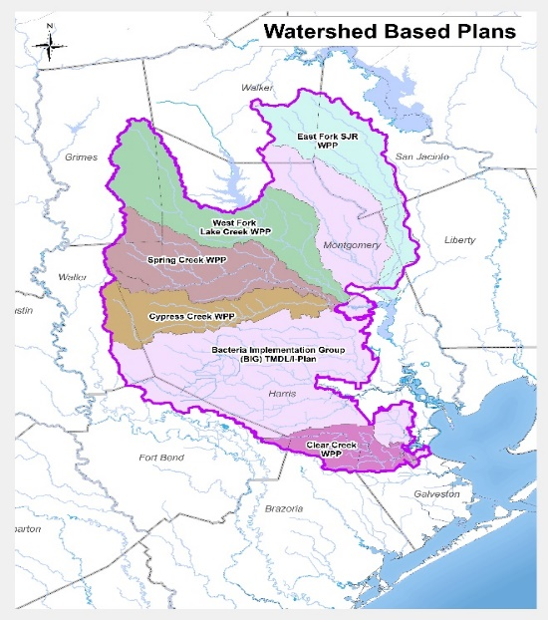
Figure 5. Watershed Protection Plan projects within the BIG project area

SPOTLIGHT ON SUCCESS
Highlighting successful projects is an important part of the BIG Annual Report. The BIG hopes by focusing on model bacteria reduction projects that are having an impact, presenting cost saving opportunities for organizations on tight budgets, increasing knowledge and understanding, improving operation and maintenance, and/or contributing unique and novel approaches will foster a sharing of information and lessons learned, and ultimately result in the expanded use of bacteria reduction projects across the BIG project area. While several projects follow, please note this list is not exhaustive and does not reflect the entirety of successful projects in 2022.

Airline Improvement District OSSF Program
Harris County has continued its efforts to address failing on-site sewer systems (OSSFs) in disadvantaged and underserved communities, more recently within the Airline Improvement District (AID) (Figure 6). This unique program working with the AID to cobble together a variety of funding sources, has successfully abandoned failing systems, and hooked up residents to centralized water and sewer.
The partnership of county departments and AID has been successful in fundraising via:
- Local bonds
- Community Development Block Grants (CDBG), and
- Texas Water Development Board’s (TWDB) Economically Distressed Areas Program.
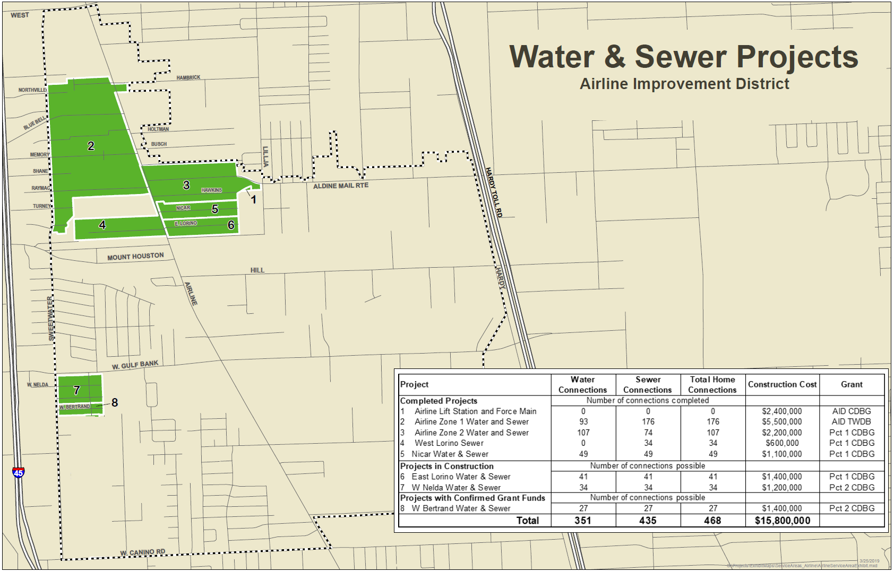
Figure 6 Airline Improvement District Projects. (Image courtesy of Harris County)
The resulting $15.8 M saw the area connect 351 water and 435 sewer hookups (Figure 6).
Previous work in the East Aldine Management District resulted in the abandonment of 1,493 OSSFs, mostly failing, at a cost of $57 M including water and sewer connections. Downstream ambient monitoring from East Aldine suggested an estimated 20 percent reduction in fecal indicator bacteria within Greens and Halls bayous. Hopefully results of the work within the Airline Improvement District will see similar results.

Multi-Use Park Facilities – A Guide to Applying Mitigation in Parks
City of Houston departments, Houston Public Works and Houston Parks and Recreation Departments joined together to identify unique, expedient, malleable, and economical strategies to mitigate future risks from flood and storm events, erosion, and aging infrastructure.
Working with Quiditty, the city documented strategies to expand environmental, economic, and social benefits of their parks while advancing storm mitigation needs identified following Hurricane Harvey.
The guidebook (Figure 7), completed November 2021, provides an overview of the city’s park infrastructure, and presents opportunities to enhance recreational amenities while managing surplus stormwater. The guide, while careful to note it is not supplanting the city’s and Harris County Flood Control District best practice stormwater design criteria manuals, is a roadmap for the abundant opportunities that park resources can avail to address stormwater while selectively enhancing recreation, aesthetics, wildlife habitat, and stormwater quality.
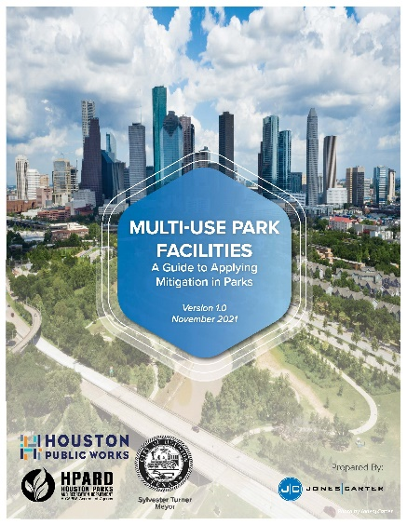
Figure 7 Guidebook Front Cover

Green Infrastructure Best Practice Monitoring and Research
Conducting best practice monitoring and research is a key component of the BIG I-Plan. Identifying practices that work to effectively reduce bacteria is needed to foster greater use of green infrastructure and other best practices. Texas AgriLife, Environmental Institute of Houston (EIH), and the Houston Advanced Research Center (HARC) are helping our partners to illuminate green infrastructure potential.
Texas AgriLife’s Texas Community Watershed Partners program reported on initial efforts to evaluate the water quality potential of three stormwater wetlands within the BIG Project Area: University of Texas Recreation Park MD Anderson Campus Wetland, Exploration Green Recreation Park Phase 1 Stormwater Wetland, and Proton Therapy Parking Lot Expansion Wetland Basin MD Anderson South Campus. The program continues to evaluate stormwater wetlands at Exploration Green.
The University of Houston at Clear Lake’s EIH has been working with the Harris County Flood Control District to evaluate floating wetlands. Floating wetlands present an opportunity to retrofit wet-bottom detention basins with emergent wetlands (Figure 8).
Figure 8 Floating wetlands (photo by Kaylei Chau, EIH)
HARC is working with the City of Houston on several capital improvement projects that are incorporating permeable pavers and biofiltration practices. The goal of the project is to monitor the practices and document their efficacy.
These three monitoring and research efforts, while inconclusive at this early stage in reducing fecal bacteria, are important and hopefully will result in filling data gaps and assist the BIG with refining future bacteria reduction messaging and outreach.

PROGRESS REPORT
Ultimate success for the BIG will be achieved when the waters assessed by the state are no longer considered impaired, meaning they meet the state contact recreation standard. Achieving that goal requires annually assessing progress to determine what is working and what is not working, looking critically at what each of the BIG partners is doing to further the goals set forth in the I-Plan, sharing information, and coordinating future implementation activities. This Annual Report is meant to be a mechanism for annual assessment, encouraging efforts that appear to be working and redirecting implementation that seems to be falling short. It is also an opportunity to look at the I-Plan to see if expectations are being met or if some activities need further refinement.
This report is based on information given to H-GAC through the workgroup process by stakeholders already involved in the BIG’s planning effort. This report includes activities through December 2022.

I-PLAN
There are 11 implementation strategies and 38 implementation activities described in the I-Plan and laid out in this report. Activity goals, an assessment, and a summary of implementation efforts conducted throughout the 2022 calendar year are presented for each (Table 1).
The BIG is in the process of revising the I-Plan. The goal of the revision is to:
- Update the I-Plan with new information and lessons learned after five years of implementation;
- Adjust strategies and activities due to the expansion of the project area and need to include management of forest lands and boater wastes; and
- Address activities that have not seen significant progress or have been completed.

Three big ideas to consider
With 11 strategies that include 38 activities (Table 1), the BIG focused and prioritized implementation. A review of available data and an assessment of current actions taken by BIG stakeholders suggest three key implementation strategies for local communities to consider addressing when committing resources to reduce bacteria. The first two BIG Ideas, Reduce or Eliminate Sanitary Sewer Overflows and Address Failing Onsite Sewage Facilities, directly target untreated or partially treated sewage. The third, Reduce Peak Stormwater Runoff, is a broader strategy that expands the landscape’s capacity to naturally reduce bacteria and can be an important component of a robust stormwater management plan.
- Reduce or Eliminate Sanitary Sewer Overflows (SSOs) – Develop and implement a routine illicit discharge detection and elimination (IDDE) program and prioritize rehabilitation and replacement of aging and/or undersized infrastructure, including collection systems, lift stations, and wastewater treatment facilities (Figure 9). Coordinate with other partners to develop and implement effective education and outreach with residents concerning the handling of fats, oils, and grease (FOG). Example programs include the City of Houston’s “Protect Our Pipes” and the Galveston Bay Foundation’s “Cease the Grease” programs.
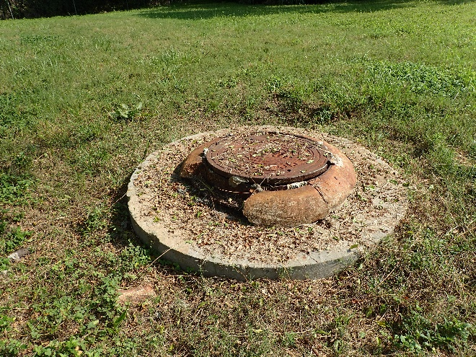
Figure 9. Aging infrastructure with evidence of sewage overflow
- Address Failing On-Site Sewage Facilities (commonly referred to as septic systems) – On-site sewage facilities are wastewater infrastructure, albeit on a much smaller and localized scale than wastewater treatment facilities. Like all infrastructure, on-site sewage facilities require periodic inspections, routine maintenance, and eventual replacement to function properly. Residents, cities, and counties should participate in on-site sewage facility function and maintenance training, encourage real estate on-site sewage facility inspections at the time of property sale, and increase the number of resident or water professional inspections. Local governments, as needed, should seek, and make funding available to help incentivize on-site sewage facility rehabilitation or replacement and promote connections to centralized waste treatment for areas with chronically failing on-site sewage facilities.
- Reduce Peak Stormwater Runoff – Concrete and other impervious surfaces, particularly when linked together (i.e., gutter to driveway to roadway) increase the speed at which stormwater – and the bacteria it carries – reaches a water body. Pervious surfaces, such as native grasses and specialized, pervious concrete, interrupt the flow and decrease the volume of water to a water body and create a more disconnected drainage system (Figure 10). This allows natural processes time to mitigate bacteria. Consider expanding traditional development methods to include alternative practices that decrease use of and/or disconnect impervious surfaces in redevelopment and new-built areas. LID and green infrastructure along with other best practices are designed to reduce pollutant loads while not adversely impacting flood management. Cities and counties can encourage the use of these practices by removing potential ordinance barriers and offering incentives for their use.
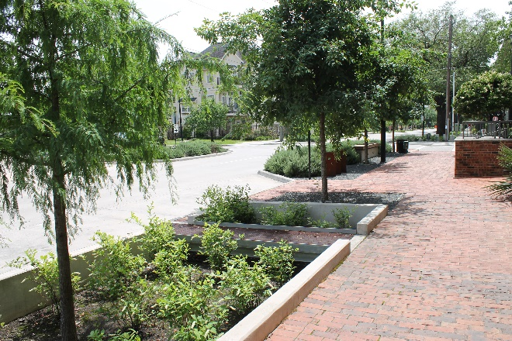
Figure 10. Curb cuts and biofiltration trenches along Bagby Street, Houston, TX
The brochure, “BIG Ideas for Cleaner Water 2017: Local Government Strategies for Improving Water Quality,” covers these topics in greater detail. The brochure is available on H-GAC’s website. Appendix C provides common resource links to available funding, outreach and education materials, more detailed reporting and data information to assist in the implementation of these three strategies and other activities of the I-Plan.

implementation strategies
Since different sources contribute to the bacteria issue in the BIG project area, there is no one-size-fits-all solution for the problem. This I-Plan is a common-sense approach for reducing bacteria in the region’s waterways. Municipalities, industries, landowners, and residents can consider a menu of water protection and implementation activities addressed by the following 11 strategies:
1. Wastewater Treatment Facilities
2. Sanitary Sewer Systems
3. On-Site Sewage Facilities
4. Stormwater and Land Development
5. Construction
6. Illicit Discharges and Dumping
7. Agriculture and Animals
8. Residential
9. Monitoring and I-Plan Revision (Figure 11)
10. Research
11. Geographic Priority Framework
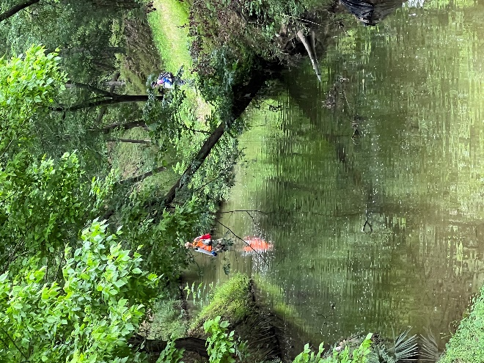
Figure 11. Targeted monitoring on Greens Bayou - Strategy 9 Monitoring

2022 implementation
The assessment of each activity includes determining progress made toward achieving the activity’s interim goal: Not Started, Initiated, In Progress, or Completed (Table 2). Additionally, each activity is assessed based on the BIG partner’s efforts to advance the activity over the year: Behind Schedule, On Schedule, Ahead of Schedule, or Completed and in Tracking (Table 1). Completed and in Tracking signifies that the activity has been completed and the BIG will continue to track. In a future I-Plan update, the activity will be reviewed to determine if a new activity is needed, a change to the assessment measure is required, or if the activity should continue and be tracked.
Overall, six activities have been completed and 32 are In Progress. The six completed activities and five of the In Progress activities have been placed into Tracking (Figure 12) to evaluate changes over time or are identified to be reviewed during the I-Plan update. Three activities were considered Ahead of Schedule and 23 On Schedule (Figure 12, Table 1). The BIG began a plan review beginning with 2019 reporting year and focused review on the activities that are Behind Schedule or those Completed and In Tracking to determine if the activities were appropriate and the measures valid. The I-Plan update will incorporate this review.

Figure 12. Implementation tracking for all 38 I-Plan Activities. Note: Completed and in Tracking is a new category added for the 2019 Annual Report.

Table 2. 2022 Implementation Progress
Strategy | # | Activity | Achievements | Progress | Status
1.0 Wastewater Treatment Facilities | 1.1 | Impose More Rigorous Bacteria Monitoring Requirements | More strict monitoring frequency requirements found in the I-Plan have not shown up in wastewater permits. The BIG submitted a letter which requested TCEQ consider this measure in 2017. It was determined that the monitoring frequency can be changed at the request of the wastewater treatment facility. A general adjustment of the frequency to the recommendation found in the I-Plan would not be carried out.  No change is to the status of this measure is reported, the BIG is modifying this measure with the I-Plan update. | Not Started | Behind Schedule
 |  |  |  | Initiated | On Schedule
 |  |  |  | In Progress | Ahead of Schedule
 |  |  |  | Completed | Tracking
1.0 Wastewater Treatment Facilities | 1.2 | Impose Stricter Bacteria Limits for WWTF Effluent | More stringent limits have been implemented for wastewater permits. Activity is programmatically complete. In 2022, there were 690 active permits in the project area, with 552 submitting discharge monitoring reports (DMRs) with 546 reporting bacteria in their DMRs. Wastewater treatment facilities with bacteria permits: 530 domestic and 16 Industrial. 449 (85%) reported 63 cfu/100 mL as their limit in 2022. | Not Started | Behind Schedule
 |  |  |  | Initiated | On Schedule
 |  |  |  | In Progress | Ahead of Schedule
 |  |  |  | Completed | Tracking
1.0 Wastewater Treatment Facilities | 1.3 | Increase Compliance and Enforcement by the TCEQ | WWTF DMRs report 97.5 percent compliance in 2022 with their permit limit, like the 97.5 percent the year prior (Grab/Max).  A review of Harris County Pollution Control (HCPC) data for WWTFs within Harris County, Daily Grab/Max compliance was 95.5%. For same plant DMRs, compliance was 95.49%. Harris County reported 100% compliance for plants greater than 5 MGD. DMRs for those sized plants, geometric means were lower on average (88.4%) compared to DMRs from smaller plants (98.5%), while HCPC is reversed at 100% and 92.1%, respectively.  February 14, 2022: Clean Waters Initiative – Navigating Texas Water Development Board Grants and Loans for Water and Wastewater. | Not Started | Behind Schedule
 |  |  |  | Initiated | On Schedule
 |  |  |  | In Progress | Ahead of Schedule
 |  |  |  | Completed | Tracking
1.0 Wastewater Treatment Facilities | 1.4 | Improved Design and Operation Criteria for New Plants | Title 30 Chapter 217 of the Texas Administrative Code was updated to reflect current permitting practices of TCEQ and updated wastewater treatment facility standards and criteria.  Harris County reviews new wastewater treatment facility plan sets and specifications. In 2022, Harris County screened 103 wastewater treatment facility plan sets for compliance with state disinfections standards. None needed to be referred to outside consultants for in-depth plan review. | Not Started | Behind Schedule
 |  |  |  | Initiated | On Schedule
 |  |  |  | In Progress | Ahead of Schedule
 |  |  |  | Completed | Tracking
1.0 Wastewater Treatment Facilities | 1.5 | Upgrade Facilities | TCEQ’s Permit Central Registry provides general information on the number of wastewater treatment facility upgrades by county. The information lacks specificity on the number of non-compliant wastewater treatment facilities that have been upgraded. | Not Started | Behind Schedule
 |  |  |  | Initiated | On Schedule
 |  |  |  | In Progress | Ahead of Schedule
 |  |  |  | Completed | Tracking
1.0 Wastewater Treatment Facilities | 1.6 | Consider Regionalization of WWTFs | The U.S. Environmental Protection Agency (EPA) and TCEQ maintain non-compliant lists. TCEQ through the latest Chapter 217 requires new wastewater treatment facilities to consider regionalization if an existing plant is within a three-mile radius.  The City of Houston reported that there was no wastewater treatment facility consolidation in 2022. | Not Started | Behind Schedule
 |  |  |  | Initiated | On Schedule
 |  |  |  | In Progress | Ahead of Schedule
 |  |  |  | Completed | Tracking
1.0 Wastewater Treatment Facilities | 1.7 | Use Treated Effluent for Facility Irrigation | TCEQ’s Permit Central Registry provides general information on the number of wastewater treatment facility applications for reuse by County. | Not Started | Behind Schedule
 |  |  |  | Initiated | On Schedule
 |  |  |  | In Progress | Ahead of Schedule
 |  |  |  | Completed | Tracking
2.0 Sanitary Sewer Systems | 2.1 | Develop Utility Asset Management Programs (UAMPs) for Sanitary Sewer Systems | TCEQ’s voluntary sanitary sewer overflow initiative has 16 wastewater treatment facility operators participating as of 2018.  H-GAC, TCEQ and EPA offer technical training and workshops tailored to encourage the use of life-cycle maintenance and dedicated wastewater treatment facility and sanitary sewer funding.  The City of Houston and the EPA have agreed to the city’s plan to address the city’s sanitary sewer overflows. | Not Started | Behind Schedule
 |  |  |  | Initiated | On Schedule
 |  |  |  | In Progress | Ahead of Schedule
 |  |  |  | Completed | Tracking
2.0 Sanitary Sewer Systems | 2.2 | Address Fats, Oils, Grease, and Wipes | Several model fats, oils, and grease (FOG) programs are available from the City of Houston, San Jacinto River Authority and H-GAC.  There were 456 reported SSOs in 2022, down from 829 in 2021, and even further from the high of 1,763 in 2017 (Hurricane Harvey). From those reported SSOs, the total volume was 76 million gallons, up from 1.5 million gallons in 2021.  The largest number of SSOs were attributed to grease blockages, 237 of 456, releasing an estimated 328,000 gallons of untreated sewage into the waterways. Wipes and rags was attributed to 5 SSOs and the largest volume at 75 million gallons.. | Not Started | Behind Schedule
 |  |  |  | Initiated | On Schedule
 |  |  |  | In Progress | Ahead of Schedule
 |  |  |  | Completed | Tracking
2.0 Sanitary Sewer Systems | 2.3 | Encourage Appropriate Mechanisms to Maintain Function at Lift Stations | The TCEQ upgraded portions of Title 30, Chapter 217 of the TAC, which addressed emergency power requirements. TCEQ’s Permit Central Registry provides general information on the number of Lift Station applications made by county. | Not Started | Behind Schedule
 |  |  |  | Initiated | On Schedule
 |  |  |  | In Progress | Ahead of Schedule
 |  |  |  | Completed | Tracking
2.0 Sanitary Sewer Systems | 2.4 | Improve Reporting Requirements for SSOs | There is not a searchable database online. H-GAC receives annual updates on the number of sanitary sewer overflows in the project area through a request to TCEQ.  TCEQ appears to be notified of sanitary sewer overflows as required. There were 456 reported SSOs in 2022, down from 829 in 2021, and even further from the high of 1,763 in 2017 (Hurricane Harvey). From those reported SSOs, the total volume was 76 million gallons, up from 1.5 million gallons in 2021.  TCEQ extended the electronic reporting rule till December 21, 2025 that may require MS4 Phase II permittees to report SSOs electronically. | Not Started | Behind Schedule
 |  |  |  | Initiated | On Schedule
 |  |  |  | In Progress | Ahead of Schedule
 |  |  |  | Completed | Tracking
2.0 Sanitary Sewer Systems | 2.5 | Strengthen Controls on Subscriber Systems | TCEQ was asked via letter from the BIG to consider adding a permit requirement to document subscriber systems or require subscriber system permits. There are no plans to add subscriber systems as permittees.  H-GAC maintains subscriber system sample contracts via its website. | Not Started | Behind Schedule
 |  |  |  | Initiated | On Schedule
 |  |  |  | In Progress | Ahead of Schedule
 |  |  |  | Completed | Tracking
2.0 Sanitary Sewer Systems | 2.6 | Penalties for Violations | The TCEQ documents its enforcement process through the Enforcement Initiation Criteria, currently revision 17. TCEQ inspectors can conduct focused sanitary sewer overflow investigations during rain events even if the facility has never reported a sanitary sewer overflow. | Not Started | Behind Schedule
 |  |  |  | Initiated | On Schedule
 |  |  |  | In Progress | Ahead of Schedule
 |  |  |  | Completed | Tracking
3.0 Onsite Sewage Facilities | 3.1 | Identify and Address Failing Systems | H-GAC maintains the on-site sanitary sewage facility permit database that shows permits by age, authorized agent, and the number of on-site sewage facilities per square mile. In 2021, there were 57,739 permitted OSSFs and an estimated 124,357 without permits. H-GAC received paper copies of older Harris County permits in 2023. These are being digitized and an update will be made for 2024.  Harris County and the East Aldine Management District has worked to install sewer service in the East Aldine region using grant funding, $57.6 M. There have not been any new sewer connections since 2019, as the partners await future funding.  Harris County and East Aldine Management District had made 846 connections and abandoned a total of 1,493 systems since 2014. Many of the abandoned OSSFs were failing as evidenced by violations.  Harris County and the Airline Improvement District continue to install sewer service in the Airline region using grant funding, $15.8 M. Harris County and the Airline Improvement District had made 24 connections to new sanitary service in 2022 for a total of 435 since 2017. Forty-nine OSSFs were abandoned in 2022 for a total of 558 since 2017. Many of the abandoned OSSFs were failing as evidenced by violations.  H-GAC addresses failing systems through a supplemental environmental project. No new systems were repaired or replaced in 2022. Since 2018, 11 systems have been repaired or replaced, while 12 await funding. | Not Started | Behind Schedule
 |  |  |  | Initiated | On Schedule
 |  |  |  | In Progress | Ahead of Schedule
 |  |  |  | Completed | Tracking
3.0 Onsite Sewage Facilities | 3.2 | Address Inadequate Maintenance of OSSF | Model on-site sewage facility regulations and policies are available online. H-GAC created a website for homeowners, homebuyers, local governments, and real estate professionals.  2022 Harris County hosted its 12th annual OSSF seminar for water professionals. The two-day webinar reached 244 attendees. The two-day event presented new innovations, best practices, and rules and enforcement updates. | Not Started | Behind Schedule
 |  |  |  | Initiated | On Schedule
 |  |  |  | In Progress | Ahead of Schedule
 |  |  |  | Completed | Tracking
3.0 Onsite Sewage Facilities | 3.3 | Legislation and Other Regulatory Actions | House Bill 2771 was enacted in September 2017 to create a dedicated fund using $10 from OSSF application fees. TCEQ will use the fund for competitive research grants.  Harris County hosted the 12th Annual Wastewater Seminar in May 2022 with 244 water quality professionals in attendance. The two-day event presented new innovations, best practices, and rules and enforcement updates. | Not Started | Behind Schedule
 |  |  |  | Initiated | On Schedule
 |  |  |  | In Progress | Ahead of Schedule
 |  |  |  | Completed | Tracking
4.0 Stormwater & Land Development | 4.1 | Continue Existing Programs | Two phase I municipal separate storm sewer systems (MS4s) permits (Joint Task Force [JTF] and Pasadena) and 129 MS4 phase II permits are partially or fully found in the BIG project area. About 42.21% of the BIG project area can be classified as within the US Census Urbanized Area as defined by 50,000 population qualifying for Phase II designation.  TCEQ renewed the MS4 Phase II permit on January 24, 2019. Notable changes include a lower benchmark for TSS, 50 mg/L; requirement to post annual reports on MS4 website; and Level 4 MS4s control of floatables and evaluation of flood management practices for impact on water quality.  The renewal of the Phase II program has been extended till August 2024. The renewal permit adds clarification that permittees discharging to impaired water bodies with a TMDL for bacteria must refer to the I-Plan for BMPs or implement proposed and approved BMPs. Also added more specific BMPs and measurable goals, activities, and deadlines.  Galveston Bay Foundation’s WaterMyYard Tool was used by 49,127 residents in 2022 to reduce water consumption and help reduce stormwater runoff. | Not Started | Behind Schedule
 |  |  |  | Initiated | On Schedule
 |  |  |  | In Progress | Ahead of Schedule
 |  |  |  | Completed | Tracking
4.0 Stormwater & Land Development | 4.2 | Model Best Practices | Harris County Flood Control District continues to host and update the Regional BMP Database. H-GAC manages a LID/Green Infrastructure online resource. | Not Started | Behind Schedule
 |  |  |  | Initiated | On Schedule
 |  |  |  | In Progress | Ahead of Schedule
 |  |  |  | Completed | Tracking
4.0 Stormwater & Land Development | 4.3 | Encourage Expansion of Stormwater Management Programs | There are over 129 municipalities and utility districts in the BIG project area subject to the MS4 Phase II General Permit.  City of Houston GI Incentive Program was kicked-off and underway in 2021. The city inventoried its parklands for potential green infrastructure opportunities.  Harris County maintains a detention offset program for developers that incorporate stormwater quality practices within their projects.  In 2022, GBF hosted 8 rain barrel workshops.  H-GAC has a grant to evaluate BMP monitoring data to recommend practices best suited to this region. Project funding was awarded in 2020 and the project got underway in 2022.  Workshops are held to encourage the use of bacteria reduction measures. The number of workshops was low due to COVID-19.  - Bayou Preservation Association – 19th Annual Symposium September 28-29, 2022: Cost of Doing Nothing – Opting for Resilience.  - Texas AgriLife Extension Sustainable Blue-Green Infrastructure and the Urban Landscape, October 7, 2022.  - February 14, 2022: Clean Waters Initiative – Navigating Texas Water Development Board Grants and Loans for Water and Wastewater. | Not Started | Behind Schedule
 |  |  |  | Initiated | On Schedule
 |  |  |  | In Progress | Ahead of Schedule
 |  |  |  | Completed | Tracking
4.0 Stormwater & Land Development | 4.4 | Promote Recognition Programs for Developments that Voluntarily Incorporate Bacteria Reduction Measures | H-GAC developed an award program, Water Innovation Strategies of Excellence Awards (WISE). The program was released in 2018 and the second annual awards were to be given in May 2020 for projects completed in 2019 or prior. The awards were delayed due to COVID-19. They are expected to be awarded in February 2023.  City of Houston is including a reward program as part of their initiative to expand the use of green infrastructure practices in development projects within the city. | Not Started | Behind Schedule
 |  |  |  | Initiated | On Schedule
 |  |  |  | In Progress | Ahead of Schedule
 |  |  |  | Completed | Tracking
4.0 Stormwater & Land Development | 4.5 | Provide a Circuit Rider Program | H-GAC maintains a LID and green infrastructure website and toolkit. There are 90 projects that can be located via an interactive map on the website. | Not Started | Behind Schedule
 |  |  |  | Initiated | On Schedule
 |  |  |  | In Progress | Ahead of Schedule
 |  |  |  | Completed | Tracking
4.0 Stormwater & Land Development | 4.6 | Petition TCEQ to Facilitate Reimbursement of Bacteria Reduction Measures | TCEQ reimburses for water quality features. Contact TCEQ for questions or coordination for reimbursement. | Not Started | Behind Schedule
 |  |  |  | Initiated | On Schedule
 |  |  |  | In Progress | Ahead of Schedule
 |  |  |  | Completed | Tracking
5.0 Construction | 5.1 | Increase Compliance with and Enforcement of Stormwater Management Permits | The City of Houston and Harris County manage mature programs to address construction site compliance. City of Houston reports onsite education is a big factor in ensuring compliance. | Not Started | Behind Schedule
 |  |  |  | Initiated | On Schedule
 |  |  |  | In Progress | Ahead of Schedule
 |  |  |  | Completed | Tracking
6.0 Illicit Discharge Detection and Elimination | 6.1 | Detect and Eliminate Illicit Discharges | Analysis of MS4 annual reports indicated that MS4 operators have regulatory mechanisms in place and procedures for detecting illicit discharges, including mapping to meet 10-year goal. Reporting of the number identified and addressed remains a work in progress.  H-GAC and Bayou Preservation Association with funding from TCEQ, completed targeted monitoring surveys within the BIG project area. Project identified several potential sources and is working with the City of Houston for further assessment. The project partners anticipate additional funding in 2022.  H-GAC and the Environmental Institute of Houston completed a targeted monitoring project using Clean Rivers Program funding. Project results identified several potential sources which were reported to local jurisdiction. Additionally, several assessment units were identified as needing further survey work. The partners anticipate receiving new funding in 2022.  A model wet and dry weather discharge monitoring program for local governments is available online. | Not Started | Behind Schedule
 |  |  |  | Initiated | On Schedule
 |  |  |  | In Progress | Ahead of Schedule
 |  |  |  | Completed | Tracking
6.0 Illicit Discharge Detection and Elimination | 6.2 | Improve Regulation and Enforcement of Illicit Discharges | MS4 Phase II operators review and implement regulations as a permit requirement. H-GAC continues to compile existing regulations. H-GAC maintains an online resource of enforcement topical presentations given at environmental workshops held at H-GAC.  Citizen reporting tools are available to assist local governments find illicit discharges and illegal dumping – 311 and the Galveston Bay Action Network are examples.  - In 2022, there were 27 pollution reports to GBAN. Of these, there were one reports for each of abandoned crab traps, septic systems and pet waste, two each for unknown chemicals, fish kills, sanitary sewer overflows, and storm drain issues, and 14 for trash and litter. | Not Started | Behind Schedule
 |  |  |  | Initiated | On Schedule
 |  |  |  | In Progress | Ahead of Schedule
 |  |  |  | Completed | Tracking
6.0 Illicit Discharge Detection and Elimination | 6.3 | Monitor & Control Waste Hauler Activities | No waste hauler tracking fleet program has been identified for a pilot project. City of Houston maintains a mature waste hauler tracking program.  Potential online tracking programs have been developed (e.g., Track My FOG). Dallas maintains a program that uses Scantron device (XC2 and Pearson Scan Tool Software) to upload manifests. | Not Started | Behind Schedule
 |  |  |  | Initiated | On Schedule
 |  |  |  | In Progress | Ahead of Schedule
 |  |  |  | Completed | Tracking
7.0 Animals, Agriculture | 7.1 | Promote Increased Participation in Existing Programs for Erosion Control Nutrient Reduction, and Livestock Management | Natural Resources Conservation Service and Texas State Soil and Water Conservation Board manage and promote land management programs in the project area. The Texas Forest Service works with landowners with forest product management.  Stakeholders recommended expanding the use of water quality management plans and conservation management plans. One suggestion is to seek a modification to property tax assessments to allow stacking of water quality property tax exemption on to an agriculture or conservation land exemption. | Not Started | Behind Schedule
 |  |  |  | Initiated | On Schedule
 |  |  |  | In Progress | Ahead of Schedule
 |  |  |  | Completed | Tracking
7.0 Animals, Agriculture | 7.2 | Promote the Management of Feral Hog Populations | County Extension Agents report holding one-on-one meetings with landowners to address feral hogs.  Texas AgriLife, lead agency for feral hog management, is looking into baiting research.  H-GAC estimated watershed level feral hog populations within the BIG – total population estimated at 7,891. | Not Started | Behind Schedule
 |  |  |  | Initiated | On Schedule
 |  |  |  | In Progress | Ahead of Schedule
 |  |  |  | Completed | Tracking
8.0 Residential | 8.1 | Expand Homeowner Education Efforts Throughout the BIG Project Area | H-GAC continued the series of Clean Water Initiative workshops:  - April 28, 2022 – H-GAC Web Tools  - June 16, 2022 – Education, Outreach, and Volunteer Coordination.  In 2022, Galveston Bay Foundation provides outreach and education, including:  - Rain barrel workshops – 264 barrels distributed to 279 participants at eight events.  - Boater waste education – 1,093 education bags distributed.  - Cease the Grease Campaign Delivered 300 funnels and scrapers.  Texas AgriLife’s Texas Coastal Watershed Partners’ outreach and technical assistance, included:  - Texas AgriLife Extension Sustainable Blue-Green Infrastructure and the Urban Landscape, October 7, 2022, in Harris County.  - Exploration Green – volunteers and planting events.  - Galveston and Brazoria County (includes Clear Creek and Jarbo Bayou) Coalition seeks to implement watershed-based plans in the two counties.  Bayou Preservation Association – 19th Annual Symposium September 28-29, 2022: Cost of Doing Nothing – Opting for Resilience. | Not Started | Behind Schedule
 |  |  |  | Initiated | On Schedule
 |  |  |  | In Progress | Ahead of Schedule
 |  |  |  | Completed | Tracking
9.0 Monitoring and I-Plan Revision | 9.1 | Continue to Utilize Ambient Water Quality Monitoring and Data Analysis | The region’s Clean Rivers Program's ambient monitoring data forms the backbone of assessments used in this report. Eight monitoring partners collect ambient data at 208 monitoring sites in the BIG project area. Additional data is provided by the network of 19 Texas Stream Team volunteers. | Not Started | Behind Schedule
 |  |  |  | Initiated | On Schedule
 |  |  |  | In Progress | Ahead of Schedule
 |  |  |  | Completed | Tracking
9.0 Monitoring and I-Plan Revision | 9.2 | Conduct and Coordinate Non-Ambient Water Quality Monitoring | Harris County Flood Control District continues to monitor water quality at several detention basins. Data is uploaded to their BMP database.  In 2022, GBF collected and analyzed 343 water quality samples and processed 98 bacteria samples with the assistance of 31 water quality monitoring volunteers at 28 bay-wide locations. Of these samples, 23 of the bacteria samples (approximately 25%) exceeded the single grab recreational limit for Enterococci of 104 MPN.  As highlighted in the Spotlight Section – TX AgriLife, EIH, and HARC are engaged in green infrastructure monitoring and research.  H-GAC and BPA continue to seek funding to carry out Targeted Monitoring. Received funds in 2022 and will begin monitoring in 2023. | Not Started | Behind Schedule
 |  |  |  | Initiated | On Schedule
 |  |  |  | In Progress | Ahead of Schedule
 |  |  |  | Completed | Tracking
9.0 Monitoring and I-Plan Revision | 9.3 | Create and Maintain a Regional Implementation Database | H-GAC maintains an online Regional Implementation database | Not Started | Behind Schedule
 |  |  |  | Initiated | On Schedule
 |  |  |  | In Progress | Ahead of Schedule
 |  |  |  | Completed | Tracking
9.0 Monitoring and I-Plan Revision | 9.4 | Assess Monitoring Results and Modify I-Plan. | The BIG produces an annual report. The I-Plan has been modified through four addendums that expanded the project area and added additional TMDLs. In 2019 there were 126 impaired AUs with TMDLs. The BIG is currently revising the I-Plan. | Not Started | Behind Schedule
 |  |  |  | Initiated | On Schedule
 |  |  |  | In Progress | Ahead of Schedule
 |  |  |  | Completed | Tracking
10.0 Research | 10.1 | Evaluate the Effectiveness of Stormwater Implementation Activities | Harris County Flood Control District continues to monitor BMPs installed at detention basins.  H-GAC received a grant from the TCEQ’s Galveston Bay Estuary Program to evaluate available performance data to develop a recommended list. Project began in 2022.  As highlighted in the Spotlight Section – TX AgriLife, EIH, and HARC are engaged in green infrastructure monitoring and research. | Not Started | Behind Schedule
 |  |  |  | Initiated | On Schedule
 |  |  |  | In Progress | Ahead of Schedule
 |  |  |  | Completed | Tracking
10.0 Research | 10.2 | Further Evaluate Bacteria Persistence and Regrowth | No local or regional programs were identified in 2022. Recent discussions suggest that this work is complete. | Not Started | Behind Schedule
 |  |  |  | Initiated | On Schedule
 |  |  |  | In Progress | Ahead of Schedule
 |  |  |  | Completed | Tracking
10.0 Research | 10.3 | Determine Appropriate Indicators | EPA continues to study the use of Coliphage as surrogates for pathogens. EPA evaluated validations for two coliphage measurements methods for ambient water with an aim to publish draft criteria in 2018. Recent paper was published in 2019.  Work by researcher at Texas A&M and UH Clear Lake are studying DNA, Coliphage and other techniques along with rapid testing. Foundation work will support efforts to identify future standards. | Not Started | Behind Schedule
 |  |  |  | Initiated | On Schedule
 |  |  |  | In Progress | Ahead of Schedule
 |  |  |  | Completed | Tracking
10.0 Research | 10.4 | Additional Research Topics | House Bill 2771 went into effect on September 1, 2017. The bill requires TCEQ to award competitive grants using funds collected from the $10 on-site sewage facility permit fee. Eligible projects include research and demonstration projects for on-site sewage facility treatment technology that improves water quality, reduces costs, and/or wastewater reuse | Not Started | Behind Schedule
 |  |  |  | Initiated | On Schedule
 |  |  |  | In Progress | Ahead of Schedule
 |  |  |  | Completed | Tracking
11.0 Geographic Priority | 11.1 | Consider Recommended Criteria When Selecting Geographic Locations for Projects | H-GAC developed the Top 10 “Most Likely to Succeed” and “Most Wanted” Streams lists to help local stakeholders prioritize water quality improvements. Geographic prioritization continues to be used to target areas.  One model project The Top Five / Least Five project was completed in 2017, which can form the basis for local government investigations.  Based on the model project and previous investigations by BPA and BIG stakeholders, H-GAC and Bayou Preservation Association with TCEQ completed in 2021, a targeted monitoring survey of five AUs within the BIG project area.  H-GAC with the Environmental Institute of Houston using Clean Rivers Program funding completed a targeted monitoring survey of 10 AUs in 2021, most of which were located within the BIG project area.  H-GAC and BPA continue to seek funding to carry out Targeted Monitoring. Both received funds in 2022 and will begin monitoring late in 2022 and into 2023. | Not Started | Behind Schedule
 |  |  |  | Initiated | On Schedule
 |  |  |  | In Progress | Ahead of Schedule
 |  |  |  | Completed | Tracking

Appendix A
Acknowledgments

Texas Commission on Environmental Quality
Nicole Hall
Nicole Reed
Daniela Mejia
Jazmyn Milford
Wyatt Eason
Manashi Paul

Texas State Soil and Water Conservation Board
Brian Koch

Houston-Galveston Area Council
Justin Bower
Jessie Casillas
Bill Ervin
Cornell Evans
Steven Johnston
Todd Running
Andrea Tantillo
Rachel Windham

Animals and Agriculture Workgroup
Sam Hill, Texas A&M Forest Service
Brian Koch, Texas State Soil and Water Conservation Board
Kyle Wright, National Resource Conservation Service

Stormwater and Land Development and Construction Workgroups
Camila Biaggi, Quiddity Engineering
Jesuina Chipindula, City of Houston
Tom Douglas, Sierra Club
Teague Harris, IDS Engineering Group
Rick Felan, NASA
Justin Klump, Stormwater Solutions
Jeff Lu, Harris County
Lisa Montemayor, City of Houston
John Moss, Eco Services
Ly Nguyen, City of Houston
Sonia Philips, City of League City
Jim Robertson, Cypress Creek Flood Control Coalition
Robert Snoza, Harris County Flood Control District
Liz Stone, Quiddity

Coordination and Policy and Plan Revision Workgroups
Ralph Calvino, Terracon
Jesuina Chipindula, City of Houston
Tom Douglas, Sierra Club
Teague Harris, IDS Engineering Group
Sam Hill, Texas A&M Forest Service
Jason Maldonado, Lockwood, Andrews and Newnam
Lisa Montemayor, City of Houston
Paul Nelson, Bayou Preservation Association
Sonia Phillips, City of League City
Linda Pechacek, LDP Consultants
Jim Robertson, Cypress Creek Flood Control Coalition
Aaron Schindewolf, San Jacinto River Authority
Shane Simpson, San Jacinto River Authority
Linda Shead, Texas Coastal Partners
Brian Shmaefsky, Lone Star College
Robert Snoza, Harris County Flood Control District
Michael Thornhill, SI Environmental
Scott Tuma, Boater
Jo Wilson, Gulf Coast Authority
Natasha Zarnstorff, Galveston Bay Foundation

Research, Monitoring, and Watershed Outreach Workgroups
Karen Kottke, AECOM
Lisa Montemayor, City of Houston
Brian Shmaefsky, Lone Star College
Robert Snoza, Harris County Flood Control District

On-Site Sewage Facility and Illicit Discharges Workgroup
Raymond Beckford, Harris County
Darla Branch, Chambers County
Jesuina Chipindula, City of Houston
Kristin DeBone, TCEQ
Tom Douglas, Sierra Club
Ryan Gerlich, Texas Agrilife Extension
Frank Green, Montgomery County
Vince Jodie, Brazoria County
Miranda Jordan, TCEQ
Jeff Lu, Harris County
Tonya Mewis, Waller County
Shane Simpson, San Jacinto River Authority
Robert Snoza, Harris County Flood Control District

Wastewater Treatment Facility and Sanitary Sewer Systems Workgroup
Susie Blake, City of League City
Jesuina Chipindula, City of Houston
Tom Douglas, Sierra Club
Frank Green, Montgomery County
Teague Harris, IDS Engineering
Carol LaBreche, City of Houston
Karen Kottke, AECOM
Jeff Lu, Harris County
Jason Maldonado, Lockwood, Andrews and Newnam
Scott Nichols, Montgomery County
Robert Snoza, Harris County Flood Control District
Desta Takie, City of Houston
Michael Thornhill, SI Environmental
Jo Wilson, Gulf Coast Authority

Appendix B
Bacteria Trends
The area’s relative geometric mean is just above four times the state’s water quality standard for bacteria (Appendix B - Figure 1). This is down overall from six times the standard in 2006. While the overall bacteria trend in the BIG project area continues to decline, it appears to have leveled out with a potential increase with recent geometric means. The background, those areas outside of the BIG project area has also seen a general rise over the same timeframe.
Appendix B - Figure 1 illustrates how the rolling seven-year geometric mean for bacteria levels has changed over time (2006-2022). It is based on ambient water quality data collecting indicator bacteria samples (E. coli and Enterococci) from all Clean Rivers Program monitoring stations within the BIG project area through the calendar year 2022. Included are bacteria trend lines for the BIG (solid green line), the Expanded BIG (dash blue line) including Armand Bayou, Jarbo Bayou and East and West Fork of the San Jacinto River (EF/WF SJR), Armand Bayou (dashed purple line), EF/WF SJR (long dashed brown line), Jarbo Bayou (long-short dashed light purple line) and bacteria trend for CRP areas outside of the BIG project area (solid green line).
The lines were generated using a ratio of the geometric mean of the rolling seven years with that of the state’s contact recreation standard, either E. coli or Enterococci, 126 colony forming units (cfu)/100mL or 35 cfu/100mL, respectively. The short dashed red line represents the standard normalized by dividing by the standard. This allows both standards to be used on the same graph. The geometric means were also divided by the appropriate standard.
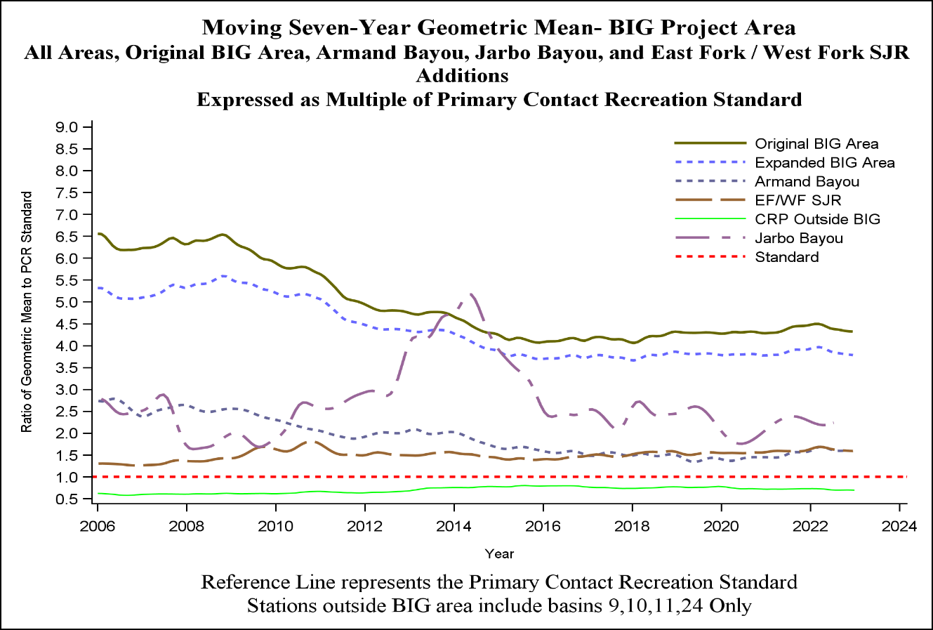
Appendix B Figure 1

Appendix C
Implementation Resources

IMPLEMENTATION RESOURCES
RESOURCE | NAME | USE | WEBSITE
FUNDING and TECHNICAL ASSISTANCE | 319 Nonpoint Source Grant | Non permitted Nonpoint Source Reduction Measures | https://www.tceq.texas.gov/waterquality/nonpoint-source/grants
FUNDING and TECHNICAL ASSISTANCE | 319 Nonpoint Source Grant | Agriculture and Silviculture Nonpoint Source Measures | https://www.tsswcb.texas.gov/programs/texas-nonpoint-source-management-program
FUNDING and TECHNICAL ASSISTANCE | 320 Estuary Program | Water Quality Improvement, Conservation, Restoration, Public Outreach and Education, and Research | https://gbep.texas.gov/
FUNDING and TECHNICAL ASSISTANCE | Clean Water State Revolving Fund | Low cost financial assistance for wastewater, reuse, and stormwater infrastructure | http://www.twdb.texas.gov/financial/programs/CWSRF/
FUNDING and TECHNICAL ASSISTANCE | EPA Water Infrastructure and Resiliency | Resource to explore innovative finance solutions | https://www.epa.gov/waterfinancecenter
FUNDING and TECHNICAL ASSISTANCE | Low Impact Development / Green Infrastructure | Guidance on use and maintenance (H-GAC) | https://www.h-gac.com/low-impact-development
FUNDING and TECHNICAL ASSISTANCE | Low Impact Development / Green Infrastructure | City of Houston Incentives for Green Infrastructure | http://www.houstontx.gov/igd/
FUNDING and TECHNICAL ASSISTANCE | Natural Resources Conservation Services Environmental Quality Incentives Program | Resource Conservation for Agriculture and Silviculture | https://www.nrcs.usda.gov/programs-initiatives/eqip-environmental-quality-incentives
FUNDING and TECHNICAL ASSISTANCE | Onsite Sewage Facility | Homeowner, real estate, and inspector technical assistance and funding | https://www.h-gac.com/on-site-sewage-facilities
FUNDING and TECHNICAL ASSISTANCE | Texas Parks and Wildlife Landowner Incentive Program | Enact conservation practices on private lands | https://tpwd.texas.gov/landwater/land/private/lip/#menu
FUNDING and TECHNICAL ASSISTANCE | Texas Water Infrastructure Coordination Committee | Identify and develop solutions to water and wastewater | https://twicc.org/resources/funding.html
FUNDING and TECHNICAL ASSISTANCE | USDA Rural Development Grant | Rural Wastewater Infrastructure | https://www.rd.usda.gov/programs-services/water-waste-disposal-loan-grant-program
FUNDING and TECHNICAL ASSISTANCE | USDA Waste and Environmental Program | Multiple assistance programs | https://www.rd.usda.gov/programs-services/all-programs/water-environmental-programs
FUNDING and TECHNICAL ASSISTANCE | Water Quality Management Plan | Soil and Water Conservation for Agriculture and Silviculture | www.tsswcb.texas.gov/index.php/programs/water-quality-management-plan
Outreach and Education | Clean Waterways | Water quality outreach and education | www.cleanwaterways.org
Outreach and Education | Clean Waters Initiative Workshops | Technical workshops covering a variety of water quality information | https://www.h-gac.com/clean-water-initiative-workshops
Outreach and Education | Coastal Communities | Nonpoint source outreach and education information | https://www.h-gac.com/coastal-communities
Outreach and Education | Fats, Oils, Grease, Wipes | Cease the Grease | http://ceasethegrease.net/
Outreach and Education | Fats, Oils, Grease, Wipes | Protect Our Pipes | https://www.publicworks.houstontx.gov/protect-our-pipes
Outreach and Education | Fats, Oils, Grease, Wipes | Patty Potty | www.pattypotty.com
Outreach and Education | Lone Star Healthy Streams | Agriculture BMPs | http://lshs.tamu.edu/bmps/
Outreach and Education | My Yard | Reduce water consumption and stormwater runoff | https://www.galvbaygrade.org/cover-stories/2023/08/water-my-yard/
Outreach and Education | Municipal Public Education | Regional Public Education Services Program | https://www.hcfcd.org/Resources/Education-Materials/Regional-Public-Education-Services-Program
Outreach and Education | Municipal Public Education | Coastal Communities | https://www.h-gac.com/coastal-communities
Outreach and Education | Onsite Sewage Facility | Public outreach and education | https://www.h-gac.com/on-site-sewage-facilities
Outreach and Education | Pet Waste | Basic information on pet wastes | www.h-gac.com/community/pet-waste/default.aspx
Reporting | City of Houston Bureau of Pollution Control and Prevention | Service helpline and pollution reporting | www.houstontx.gov/311 and 713.837.0311
Reporting | Galveston Bay Action Network | Pollution reporting in five counties surrounding Galveston Bay | www.galvbay.org/gban
Reporting | HCFCD Citizen's Service Hotline | Telephone reporting system | 713.684.4197
Reporting | Illegal Dumping | Pollution reporting system for MS4s | www.cleanbayous.org
Data | Clear Rivers Program | Ambient monitoring data | https://www.h-gac.com/clean-rivers-program/data
Data | EPA Enforcement and Compliance History Online | Permit tracking and compliance database | https://echo.epa.gov/
Data | HCFCD BMP Database | Best Management Practices Monitoring | www.bmpbase.org
Data | LID Tracking | Low Impact Development Resource | https://www.h-gac.com/low-impact-development/designing-for-impact
Data | Onsite Sewage Facility | Mapping tool | https://datalab.h-gac.com/ossf/
Data | Wastewater and Stormwater | Permit look up | www.tceq.texas.gov/agency/data/lookup-data/status-stormwater-wastewater.html



2021 Basin Summary Report - https://www.h-gac.com/clean-rivers-program/basin-highlights-summary-reports
BIG I-Plan - https://www.h-gac.com/bacteria-implementation-group/reports
https://www.tceq.texas.gov/assets/public/waterquality/swqm/assess/16txir/2016_delist.pdf
www.westfork.weebly.com www.cypresspartnership.com www.springcreekpartnership.com www.clearcreekpartnership.com www.eastforkpartnership.com
Multi-Use Facility Guidebook.pdf(Shared) - Adobe cloud storage
Clean Waters Initiative Workshops | Houston-Galveston Area Council (H-GAC) – Stormwater.
Taylor, Christie. August 2020. Initiating Water Quality Sampling of Stormwater Treatment Wetlands in Galveston Bay Watershed. Coastal Management Program -Cycle 23. Texas General Land Office. Final Report.
Stormwater Wetland Water Quality Monitoring Project - Texas Community Watershed Partners (tamu.edu)
Design, Construction, and Analysis of Floating Wetlands | University of Houston-Clear Lake (uhcl.edu)
Bare, Ryan. February 2024. Low Impact Development Construction and Performance Evaluation in the City of Houston. HARC. Presentation at Green Infrastructure and Stormwater Management Workshop.
Designing for Impact (arcgis.com)
http://www.h-gac.com/community/water/tmdl/BIG/reports.aspx
https://www.protectourpipes.org
http://www.pattypotty.com/
https://coastalcommunitiestx.weebly.com/materials.html
Enforcement Initiation Criteria (EIC) - Texas Commission on Environmental Quality - www.tceq.texas.gov
General Permit TXR040000 for Phase II (Small) MS4s - Texas Commission on Environmental Quality - www.tceq.texas.gov
https://www.galvbaygrade.org/cover-stories/2023/08/water-my-yard/
www.bmpbase.org
www.h-gac.com/community/go/LID
https://galvbay.org/work/water-protection/
www.h-gac.com/community/go/LID
https://www.h-gac.com/getmedia/aa375f0d-1c20-42ec-aaed-ff3ae5d10bca/Top5-Least5-Final%20Report-06-5-17.pdf
http://www.h-gac.com/community/environmental-enforcement/workshops.aspx
www.CleanBayous.org
www.galvbay.org/gban
https://www.trackmyfog.com/
www.h-gac.com/cwi
http://h-gac.maps.arcgis.com/apps/MapSeries/index.html?appid=a75ba4bb46ca40658066c5755a8dba6e
John F. Griffith, SCCWRP Commission, Sept. 8, 2017
Boczek, L. U.S. EPA: Proposals and Method for Coliphage as Surrogates for Environmental Pathogens. WEFTEC, Chicago, Illinois, Sept. 21-25, 2019
http://www.h-gac.com/community/water/tmdl/BIG/reports.aspx

